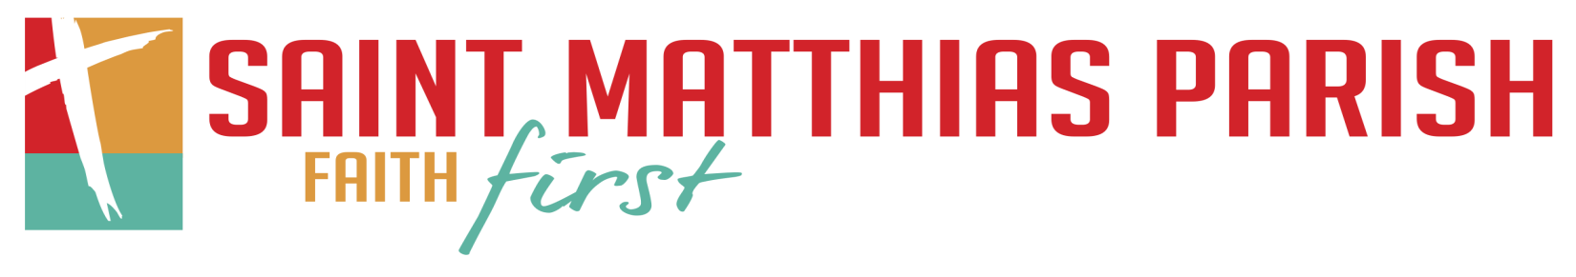

First Eucharist and First Reconciliation
Sacrament Preparation Information
2021-2022
This school year, your child is entering an exciting time in their faith life. During this year, they will have the opportunity to receive the sacraments of First Reconciliation and First Eucharist. To prepare our students for these celebrations, we provide sacrament preparation classes to complement the faith formation they receive at home and in the day school or Christian Formation program. Please see details below regarding preparation and reception of the sacraments.

First Reconciliation:
The preparation program for First Reconciliation takes place in the winter. The sacrament of First Reconciliation will be celebrated at St. Matthias Parish on Saturday, December 18th at 10:00 am. There will not be a formal penance service beforehand. Protocols for reception will be discussed at information meeting.

The preparation program for First Reconciliation is described below. Participation by parents and students at each event is required for students as they prepare to receive the sacrament.
- First Reconciliation Blessing of Students/informational meeting after each blessing (attend one and please stay for the meeting following the Mass in Steiger Hall. Please notify me in advance of which one you will attend.)
  - Saturday October 23rd at the 4 pm Mass
  - Sunday October 24th at the 8am or 10 am
- Attend one of the two First Reconciliation Parent/Student Sessions – held in the Church and Steiger Hall (RM 7).
  - Tuesday November 9th – 6:00 – 7:15 pm
  - Wednesday November 10th – 6:00 – 7:15 pm
- Complete work in the 1st Reconciliation Workbook. Workbooks will be handed out during the parent/student meetings after the blessings.
- The $35 fee for the Reconciliation preparation program can be paid at one of the meetings, at the parish office, or online at the parish website: https://stmatthias-milw.weshareonline.org/ws/opportunities/ChristianFormationPayment If you pay online, please indicate that the payment is for Sacrament Preparation in the comment section.

See the next page for a description of the First Eucharist preparation program.

First Eucharist:
The preparation program for First Eucharist takes place in the spring. The sacrament of First Eucharist will be tentatively celebrated at St. Matthias Parish on Saturday April 23rd and Sunday April 24th.

Participation by parents and students at each event is required for students as they prepare for the sacrament.
*Students will make a banner for the celebration of their First Eucharist.
- First Eucharist Blessing of Students/informational meeting (attend one and please stay for the meeting following the Mass in Steiger Hall. Please notify me in advance of which one you will attend.)
  - Saturday January 15th, 2022 at the 4 pm Mass
  - Sunday January 16th, 2022 at the 8am and 10 am
- February 8th & 16th, 2022 from 6 pm – 7:15 pm – Parent Student Session #1 – Location is Church and Steiger Hall (attend one night)
- March 8th & 9th, 2022 from 6 pm – 7:15 pm – Parent Student Session #2 – Location is Church and Steiger Hall (attend one night)
- March 29th, 2022, 6:00 pm – 7:00 pm or March 30th, 2022, 5:30 pm – 6:15 pm – First Eucharist Interviews – Steiger Hall (and RM 7 in the hall)
- Complete work in the 1st Communion Workbook. Workbooks will be given during the informational meetings after the blessings.
- Rehearsals For First Eucharist Mass – April 19th & 20th from 6-8pm on both days in the Church
- Attend your child’s First Eucharist Mass the weekend of April 23rd and April 24th.
- The $50 fee for Eucharist preparation program can be paid at one of the meetings or online at the parish website: https://stmatthias-milw.weshareonline.org/ws/opportunities/ChristianFormationPayment If you pay online, please indicate that the payment is for Sacrament Preparation in the comment section.

If you have any questions or concerns during the process, contact Peter Morello, Coordinator of Lifelong Faith Formation, by phone at 414-982-2413 or by email at pmorello@stmatthias-milw.org.

St. Matthias Parish
9306 W Beloit Road
Milwaukee, Wisconsin 53227-4313
(414) 321-0893

