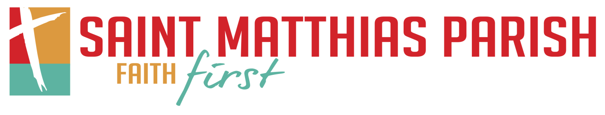

Christian Formation Registration Letter

August 2020

St. Matthias Mission Statement

St. Matthias Catholic Parish is committed to continuing the ministry of Jesus Christ. We invite and welcome all. Come…live, grow, and be challenged by the message through prayer, formation, and service.

Dear Parents and Guardians,

We hope this letter finds you and your family doing well during this time. The registration for the upcoming 2020-2021 St. Matthias Christian Formation year and the calendars for the grade school program and the high school program are in this letter.

Effect of COVID-19
At this time, per the Catholic Comeback Plan from the Archdiocese of Milwaukee, we are planning to have Christian Formation this fall with in-person classes. As we begin to plan for these in-person classes we want to ensure all families that safety is our number one priority for all students and our catechists. We realize that because of COVID-19 not all families may be comfortable sending their kids for in-person instruction. With that being said, we are committed and will be prepared to offer different options that best fit each family’s specific needs and comfortability. Please see the registration sheet or online registration and fill out all the information so we can best help you meet your family’s religious instruction needs. As we get closer to the first date of in-person classes specific details will be shared with everyone as how we plan to safely educate your children if you choose in-person instruction.

How to Register:
You may register in one of two ways. The first way is by filling out the form included with this letter and returning it to the Parish Office. You may drop off your registration during office hours (Monday – Friday 8:00 am – 4:00 pm) or after hours by putting it in the mail slot. You can also mail your registration to:
St. Matthias Parish Attn: Formation Office 9306 W Beloit Rd Milwaukee, WI 53227
The second option for registration is online at the parish website (http://www.stmatthias-milw.org). Look under the Faith Formation tab and click on “Online Registration.” For the online registration, provide the requested information and submit the completed form when you finish. You will receive a confirmation email when your registration is received, whether you register online or through the paper registration.

Registrations are due by Monday, September 28th.
*Please include all requested information, especially email addresses. We use these to send reminders and updates about the program.*

Additional Information:
Information about the Christian Formation Program can be found by visiting our website (www.stmatthias-milw.org) and clicking on the Faith Formation Tab. Information here updates regularly throughout the program. You will be able to see calendars with dates for the program, curriculum information, service opportunities, the parent handbook, and more.

Payment Information:
Check – all checks should be made out to St. Matthias. Please send them to the Parish Office using the address on the first page of this letter.
Credit Card – go online to our website: https://stmatthias-milw.weshareonline.org/ws/opportunities/ChristianFormationPayment
Payment Plans – you may choose to do a payment plan for either two or four equal payments. To do a payment plan by credit card, visit the above link. Payment plan months are September, November, January, and March.
*Fee information is included on the registration and at the payment link above.
Please note: NO family is turned away because of their financial situation. If you would like to request financial assistance for Christian Formation fees, please contact Brian Jens to receive the application for the St. Matthias Endowment Fund.

Orientation for Christian Formation:
Sunday Morning Program – K4 – 8th Grade & 9-11th grades
Wednesday, September 30th, 2020–6:00–7:00 pm–Virtual Meeting
High School Christian Formation – 9-11th grades
Thursday, October 1st, 2020 – 6:00 – 7:00 pm – Virtual Meeting

Orientation will be a virtual meeting for parents/guardians, students, and catechists. During this hour we will discuss all the changes for the upcoming year and address any questions you may have. At this time you may download or request a copy of the handbook to be sent to your house. These meetings will also be recorded and put on the parish website if you cannot make the meeting. If you cannot make the meeting and don’t have access to the internet please call the Faith Formation Office to schedule a time to talk.
Questions/Concerns?
If you have any questions regarding the Christian Formation Program, please do not hesitate to contact one of us by phone or email. We look forward to seeing you in the fall!

God Bless,

Brian Jens, Director of Lifelong Faith Formation
bjens@stmatthias-milw.org, 414-982-2406

