Children’s Liturgy of the Word
Second Sunday of Easter

Connect the dots for the picture below and then color it in.

What picture is revealed?
What are some examples of how Jesus is still present in our lives today?
1.
2.
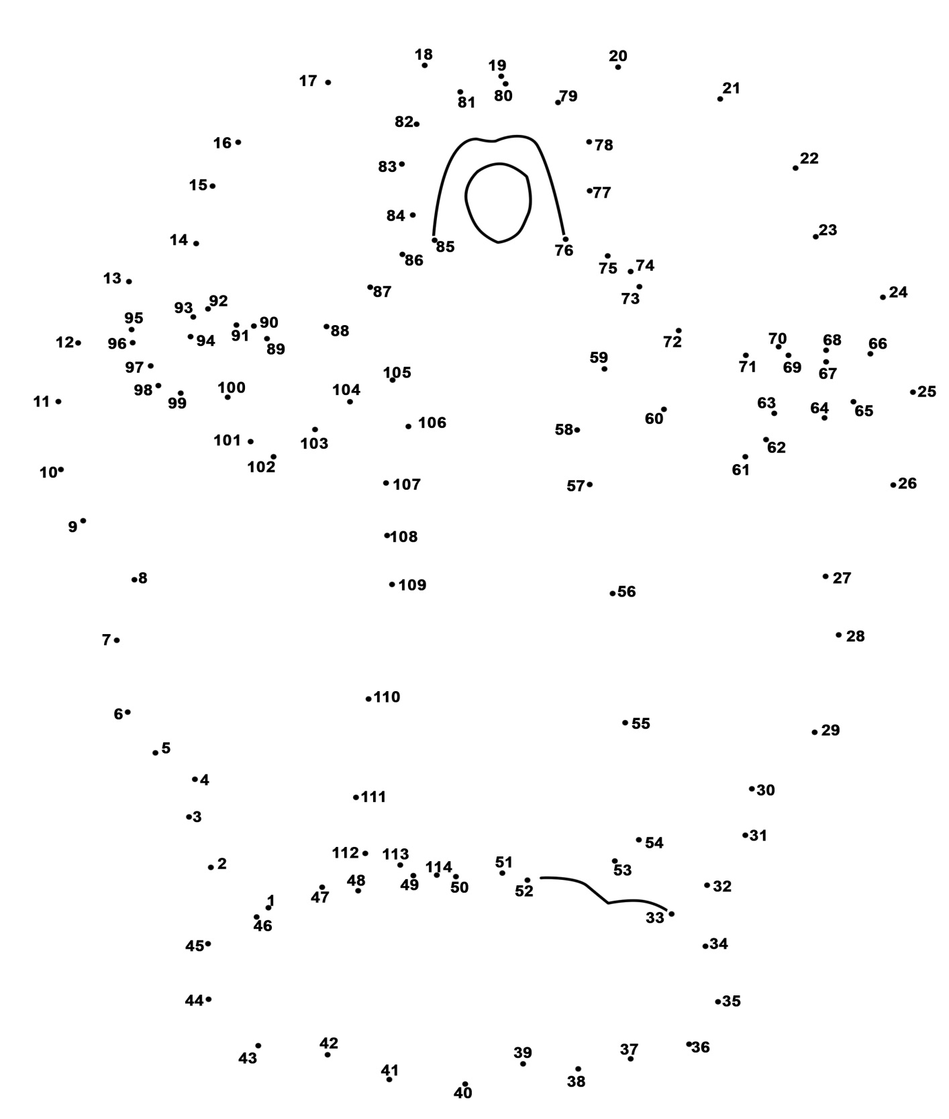
3.

